**System Testing**

Functional Requirements

At this stage, the system will carry out testing with the functional requirements that have been determined previously. The following shows the results of testing that has been done.

1. **Register for Applicant**

Testing start from the dashboard which is you enter the URL this is the dashboard page and register page.

The dashboard page



The register page

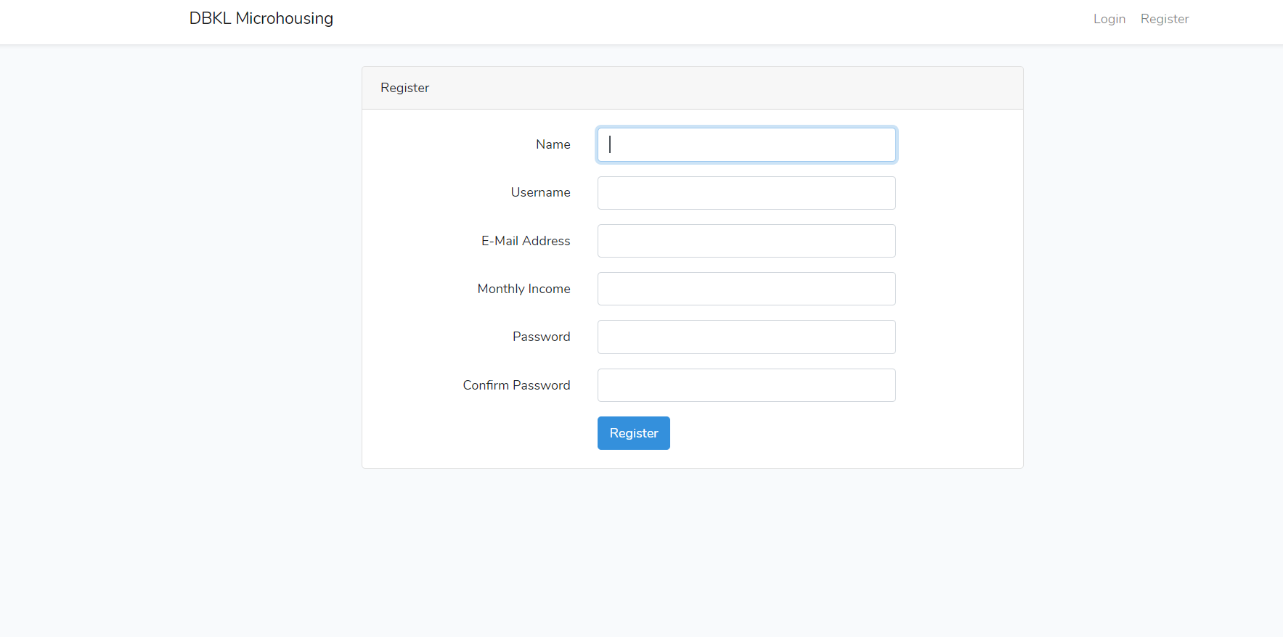

1. Applicant input blank information



1. Applicant input wrong email or username which is already used

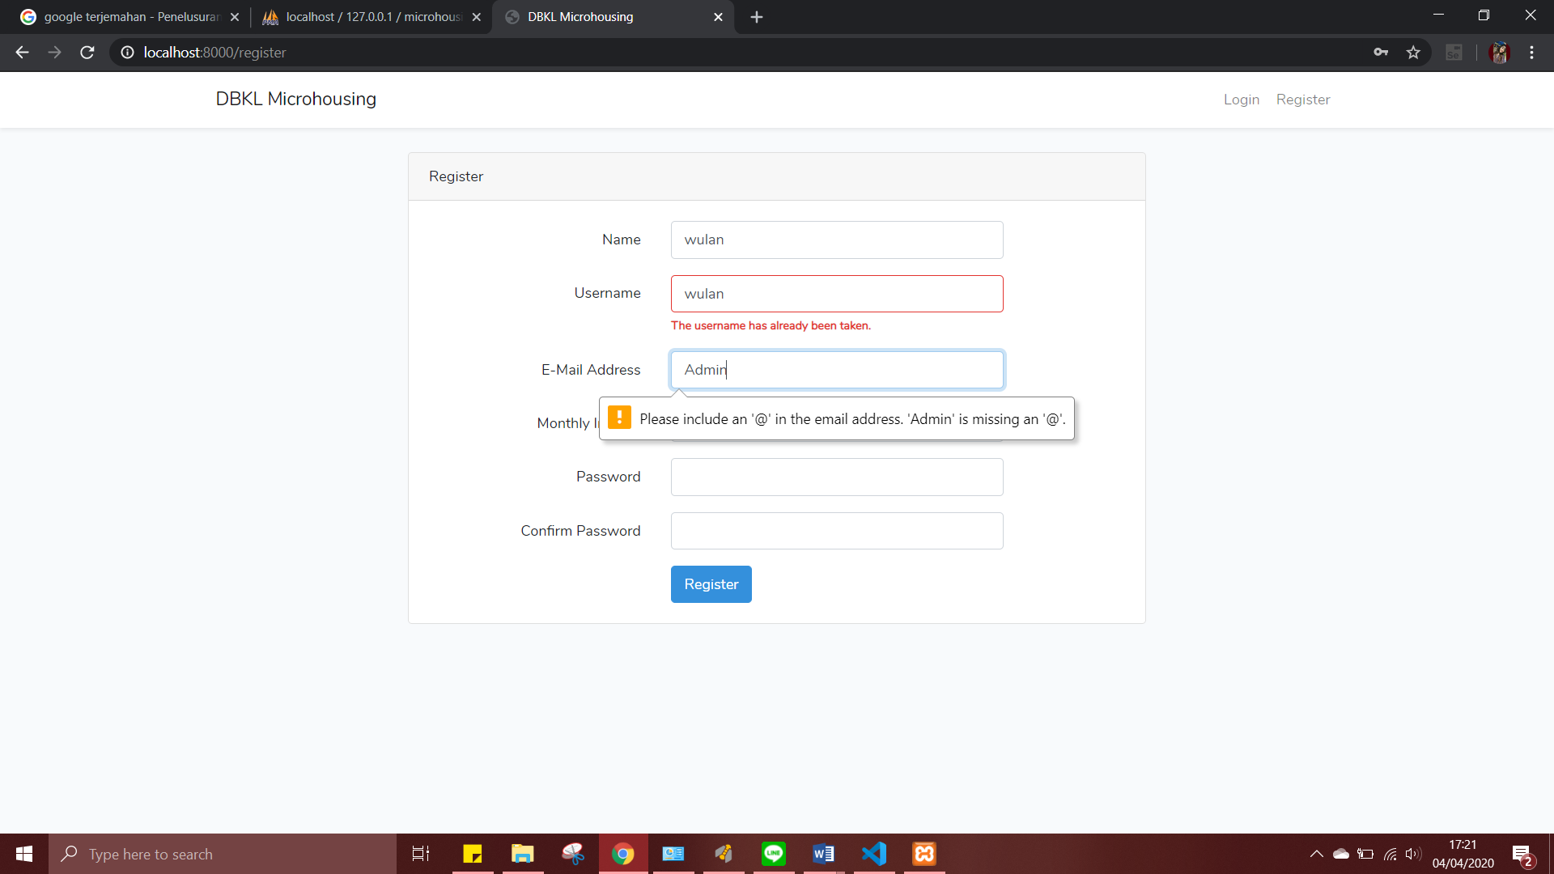

1. Applicant input invalid email and password (too short)



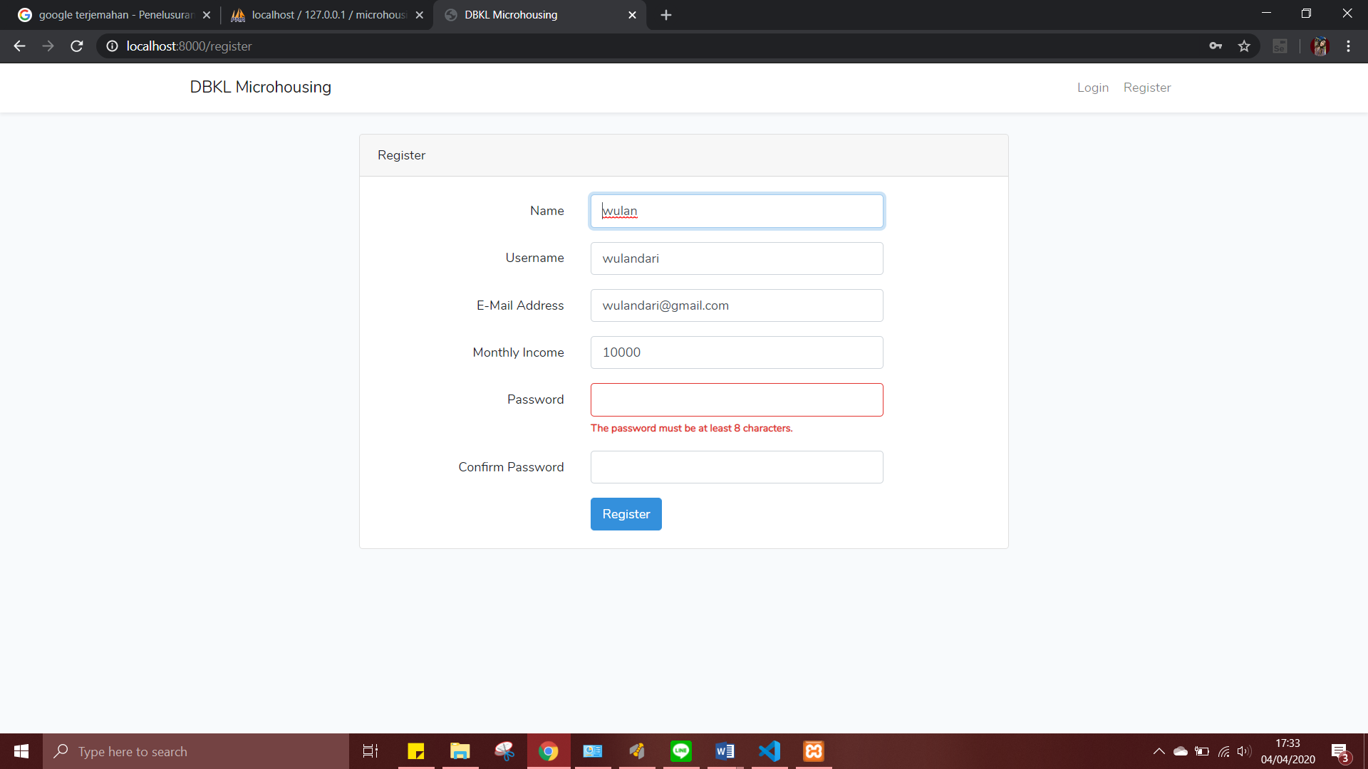

1. **Login**

Login page same location in the dashboard

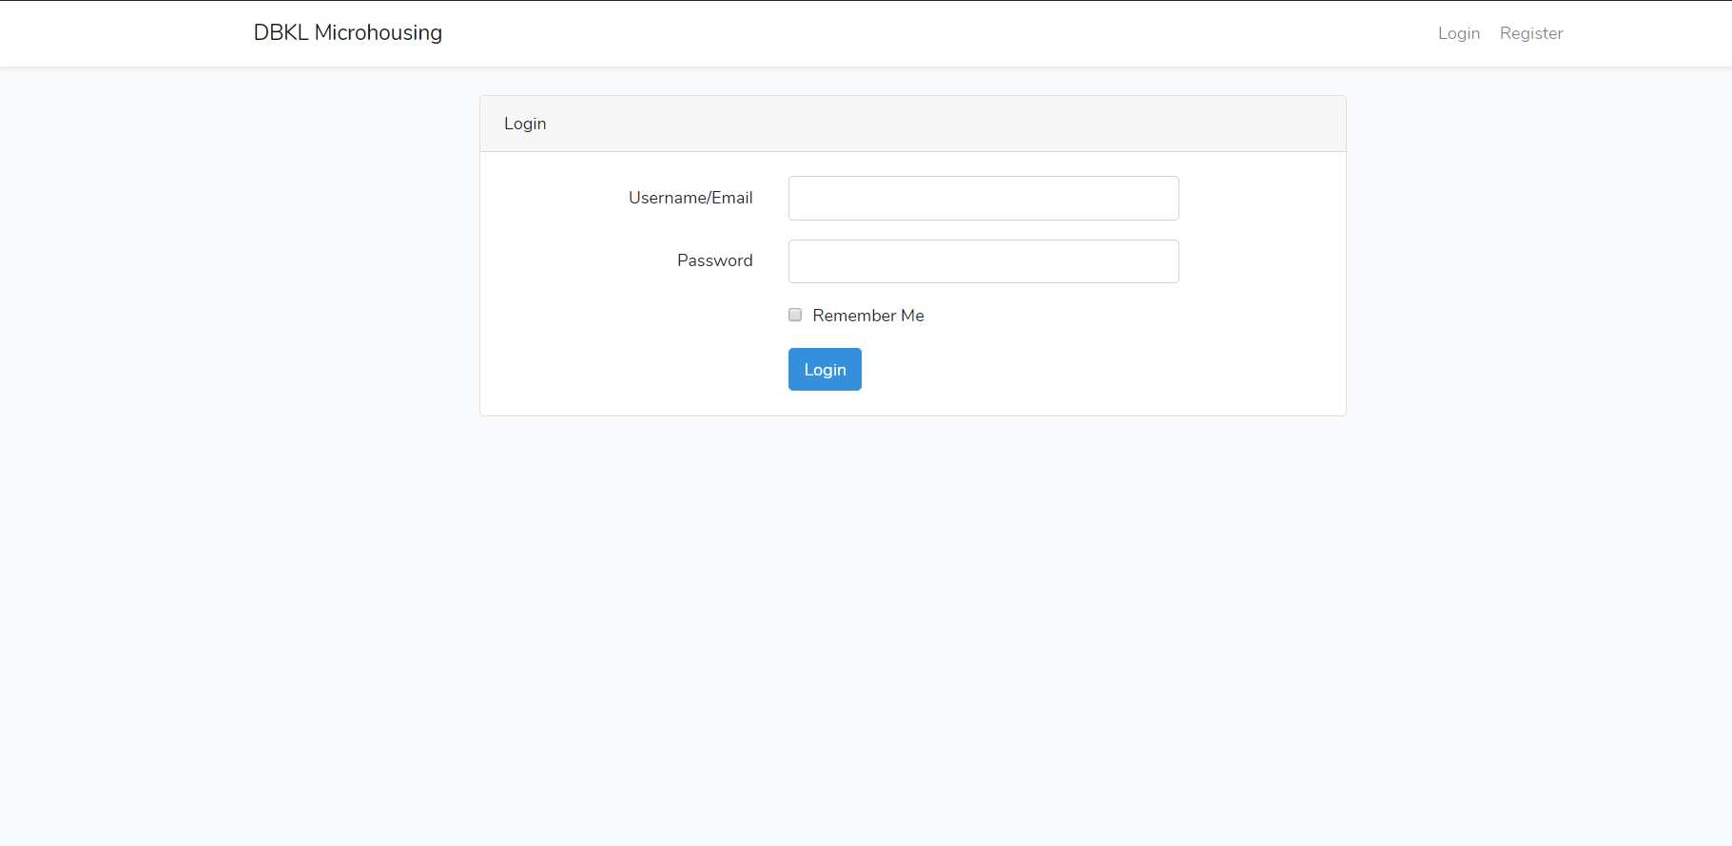

Applicant Homepage



Housing Officer Homepage

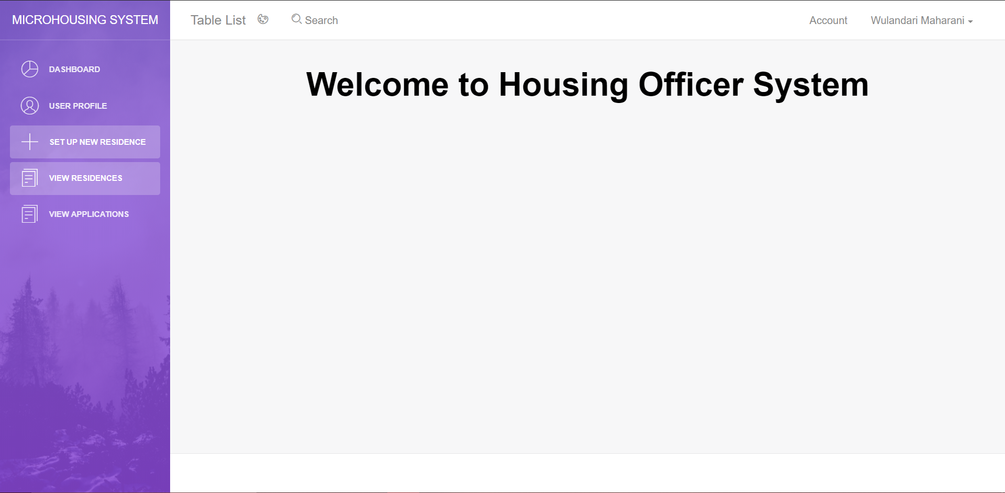

1. LogOut

After login there are logout button above the page

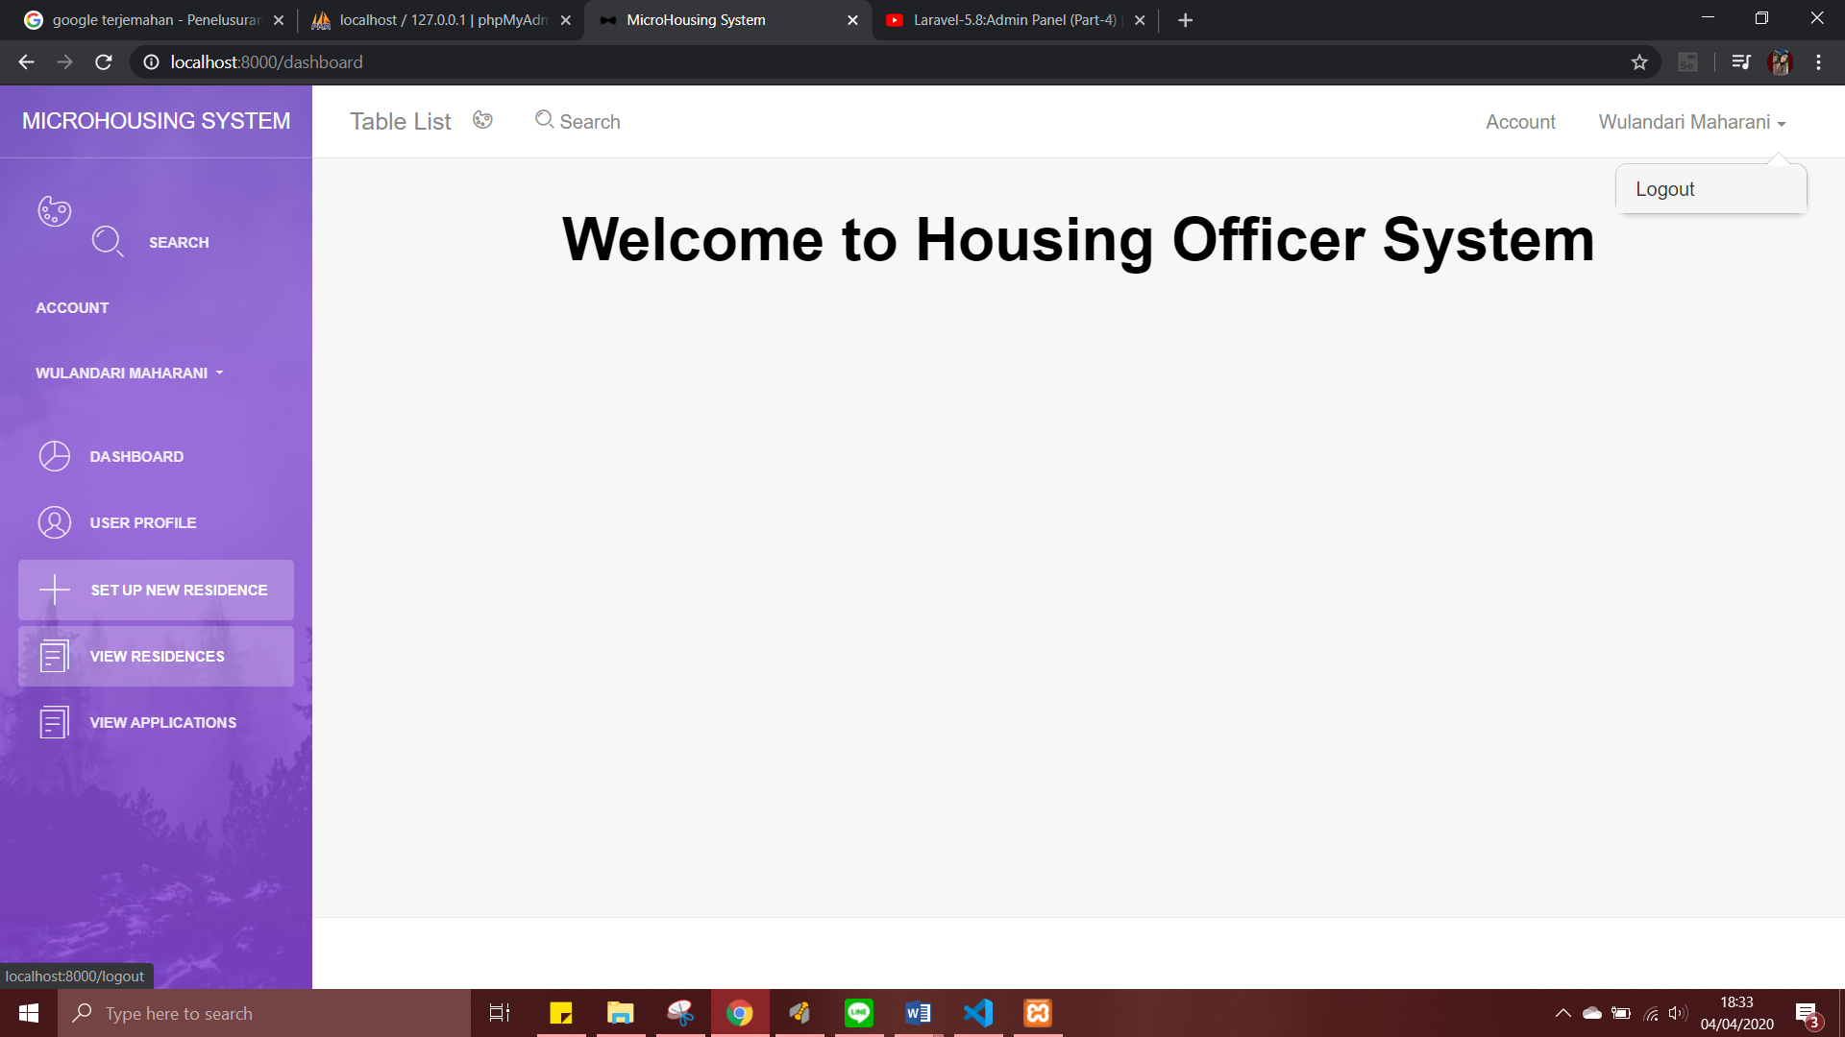

Back to the dashboard



1. **Set Up New Residence**

Set Up New Residence menu located in housingofficer page

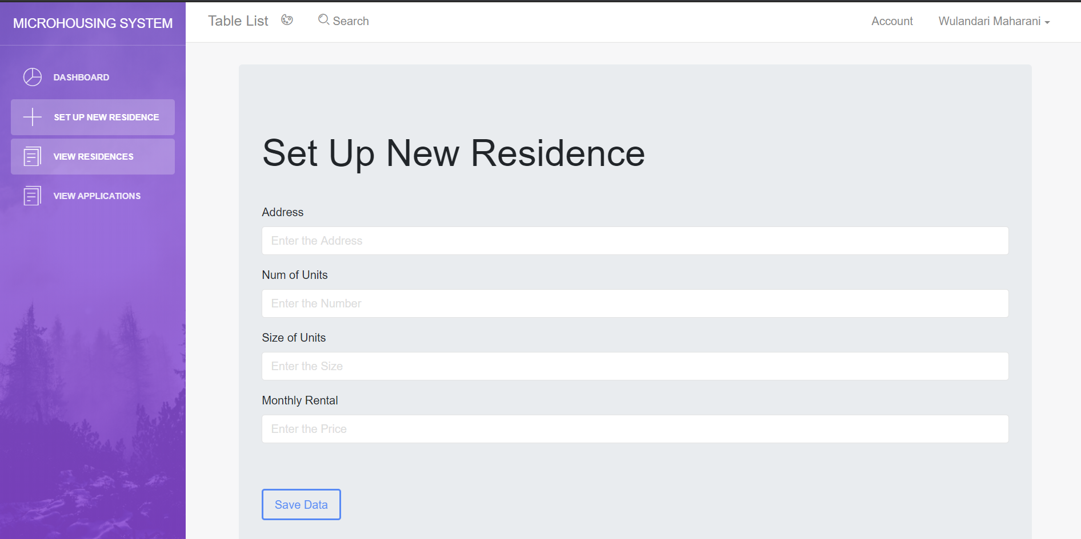

1. **View Residence Detail**

To view residence, which does the housing officer in the housing officer page already input

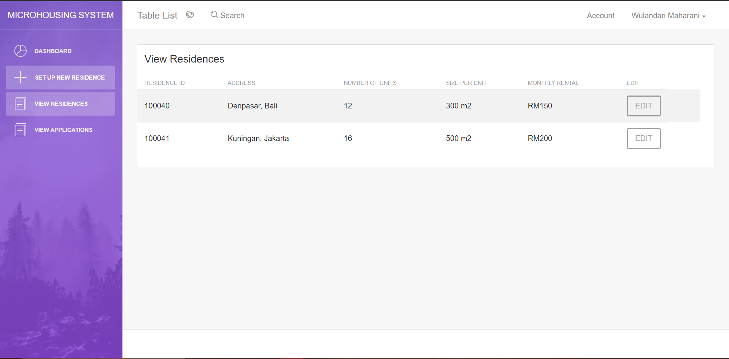

1. **Edit Residence Detail**

To edit the residence and update the data in housing officer page

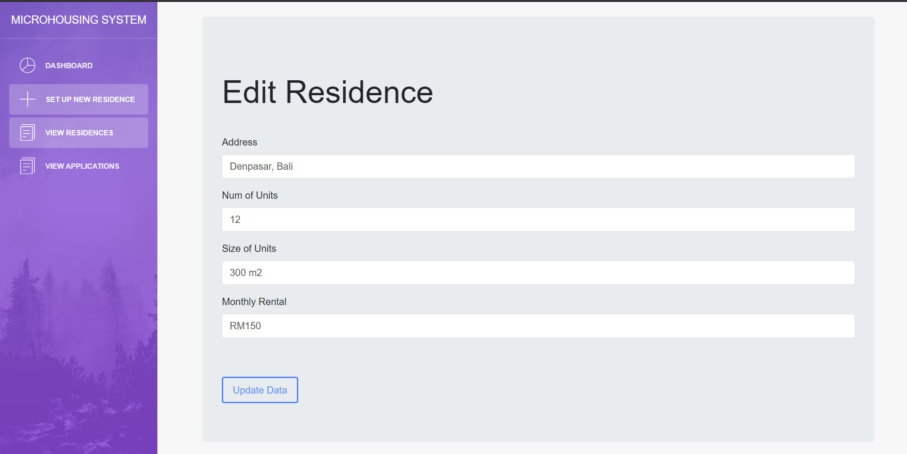

1. **View Applications**

To view the application which does the applicant already input.

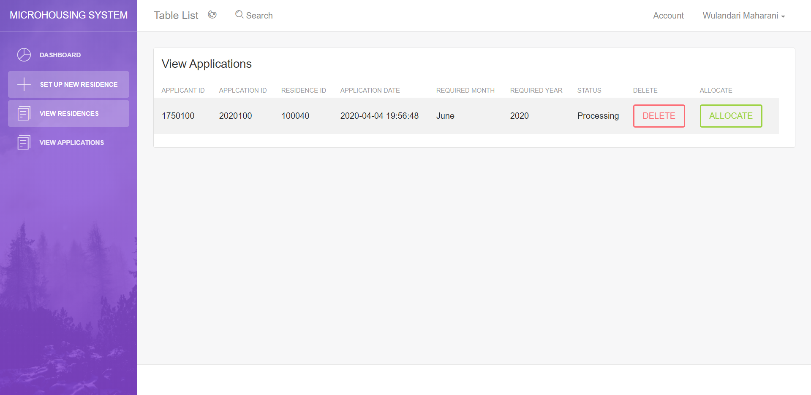

1. **Submit Application**

To submit the application

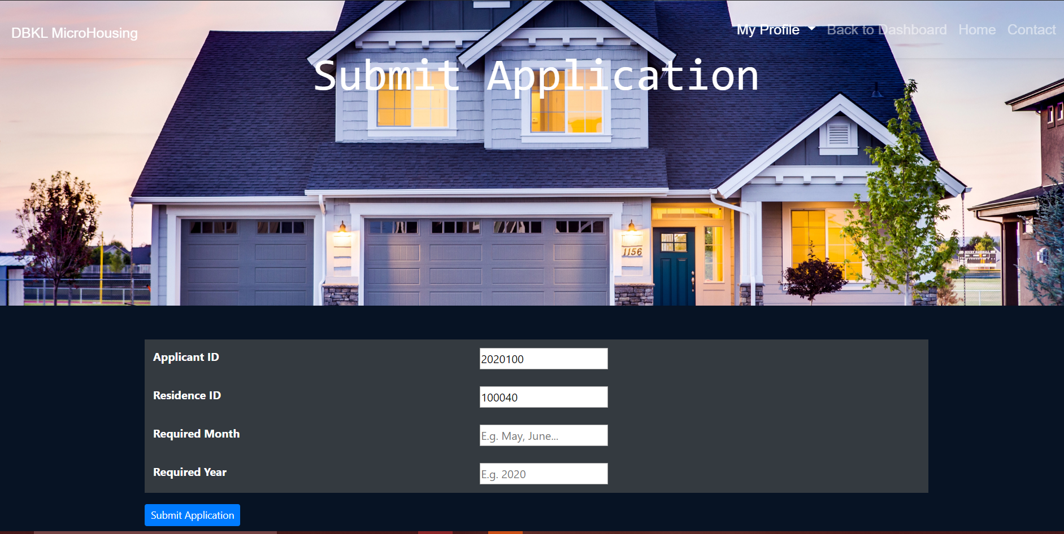

1. Applicant did not input the required month or required year

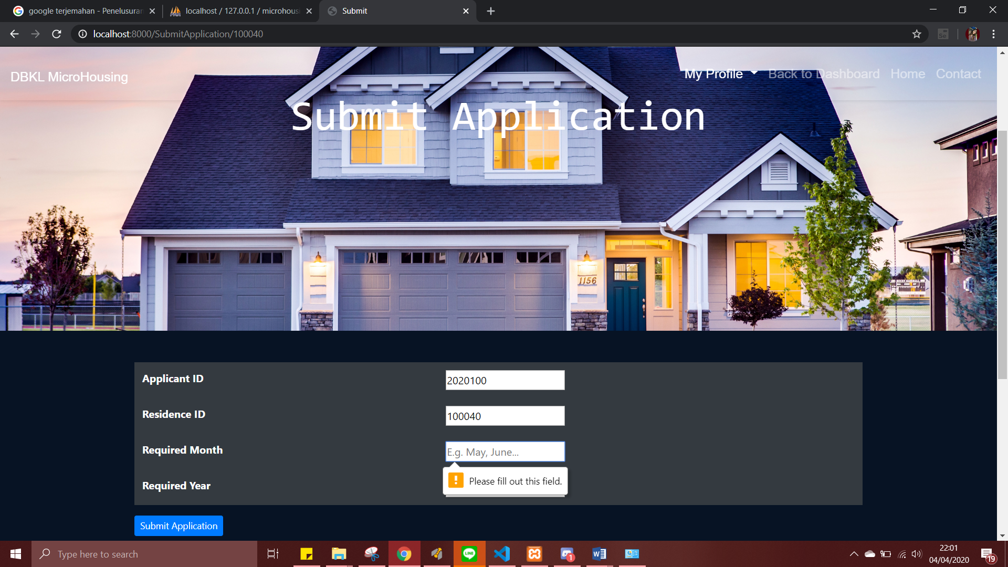

1. **View Residence (Applicant)**

To view all residence which is already make by the housing officer

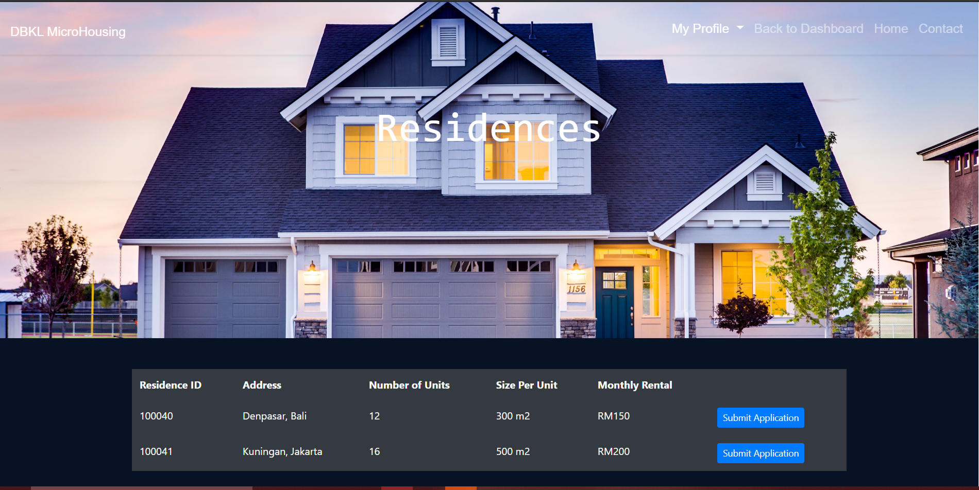

1. View Applications

To view submitted application by the applicant

